**HedgeX v1 Core [Draft]**

September 23, 2023

|  |  |  |
| --- | --- | --- |
| Alexander John Lee | Kyle Zwo | Ahmed |
| alexanderjohnlee33@gmail.com | kyleeezzzz@gmail.com |  |

Abstract

Automated market makers (AMMs) provide liquidity for trading transactions, however suffered from impermanent loss (IL) for a long time. As the AMM strategies develop from constant product, customized curve, to concentrated liquidity, the effects of impermanent loss become remarkably severe. Specifically, impermanent loss occurs for market makers when the market price deviates from the initial providing price, since the updated liquidity value (without calculation swap fee income) is always lower than the value of the holding assets and accounted as loss. To reduce the risk of the impermanent loss for liquidity providers becomes practically important. Thus, HedgeX is focusing on hedge liquidity exposure on the basis of Uniswap V3, V4 Hook, and lending protocols.

Introduction

The held asset value and liquidity value are changed over price fluctuation, as the blue and red curves shown in Fig. 1. Impermanent loss (IL) indicated by grey area between the two values. It occurs when the market price leaves the initial providing price, and continues increasing as the price deviates further. In fact, the liquidity providers aim to earn swap fees, always expecting to avoid the exposure of volatility.

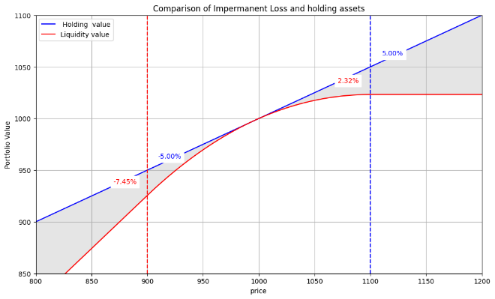

Fig. 1. Comparison of holding assets and liquidity value.

To this end, HedgeX is focusing on the design of the smart contract, which can: i) systematically calculate the risk of liquidity providers, ii) hedge the liquidity volatility using the lending protocols, and iii) automatically close the liquidity using Hook when market price exceeds the hedge range.

Based on our formulation, the hedged portfolio value versus liquidity value is plotted in Fig. 2. Within the range from price 900 to 1100, the value of liquidity shown in the red curve changes significantly from -7.45% to 2.32%. In comparison, the hedged portfolio only varies between -1.72% to 0%, which properly hedges the risk of market variation. Moreover, when the price exceeded the hedge range from price 900 to 1100, the hedged position will also be affected by the impermanent loss. Thus, an automatically Hook should be built up to close both liquidity position and hedge position once the market price arrives at the boundary to avoid loss.

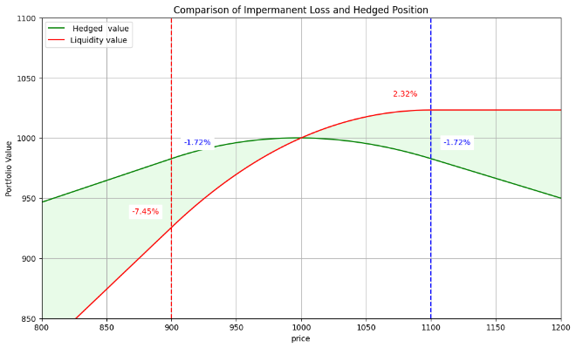

Fig. 2. Comparison of hedged portfolio and liquidity value.

Calculation

When the user provides the liquidity for the hedged swap pool, some parameters have already known, such as the user initial value, the liquidity range, and current market price, as shown in the left part of Table 1. Based on the information, we will calculate the liquidity position and the hedge position.

Table 1: Symbols used.

|  |  |  |  |
| --- | --- | --- | --- |
| Known variable | | To be solved | |
| Symbol | Notes | Symbol | Notes |
| $$V_{i}$$ | User initial value | $$x$$ | Provided amount of volatile asset (e.g., ETH) for pool |
| $$p_{a}$$ | Lower bound of a price range | $$y$$ | Provided amount of stable asset (e.g., USDC) for pool |
| $$p_{b}$$ | Upper bound of a price range | $$L$$ | Virtual liquidity |
| $$P$$ | Market Price | $$s$$ | Short amount of the volatile asset on lending protocol |
|  |  | Leverage | The leverage used on lending protocol |

As the liquidity provides, the proportion of assets in the pool should be first calculated. Uniswap V3 provides pool liquidity equations as in (1)(2) [1]. The two equations contain three unknown variables for the current stage, including the amount first and second asset needed to provide for the pool ( $x$ and $y$) and the corresponding liquidity shares ($L$). Since a user offers the initial value for the hedged pool, another equation to represent the value can be formulated as in (3).

|  |  |
| --- | --- |
| $x=L\frac{\sqrt{p_{b}}-\sqrt{P}}{\sqrt{P}∙\sqrt{p_{b}}}$ | (1) |
| $y=L(\sqrt{P}-\sqrt{p_{a}})$ | (2) |
| $V_{i}=x∙P+y$ | (3) |

The three equations can be united together to solve the unknown variables, the solution of $x$ can be derived first as in (4). On the basis, $y$ can be naturally obtained as in (5). Moreover, the corresponding liquidity shares $L$ can be achieved in terms of the solved $y$ as in (6).

|  |  |
| --- | --- |
| $x=\frac{V_{i}}{\left(\frac{\left(\sqrt{P}-\sqrt{p_{a}}\right)}{\sqrt{p_{b}}-\sqrt{P}}∙\sqrt{P}\sqrt{p_{b}}+P\right)}$ | (4) |
| $y=V_{i}-x∙P$ | (5) |
| $L=\frac{\sqrt{P}-\sqrt{p_{a}}}{y}$ | (6) |

After the calculation of provided liquidity, the value change of the liquidity can be formulated. Assuming the market price moved to the lower bound of price range, the liquidity should be swapped all to asset $x$, where $x$ at the lower bound can be calculated as in (7) and its corresponding value is represented as in (8). Likewise, when the market price arrives at the upper bound of price range, the liquidity should be swapped all to asset $y$, where $y$ at the upper bound can be calculated as in (9) and its corresponding value is represented as in (10).

|  |  |
| --- | --- |
| $x_{lower}=L\frac{\sqrt{p_{b}}-\sqrt{p_{a}}}{\sqrt{p_{a}}∙\sqrt{p_{b}}}$ | (7) |
| $$V_{lower}=x_{lower}∙p_{a}$$ | (8) |
| $y_{upper}=L(\sqrt{p_{b}}-\sqrt{p_{a}})$ | (9) |
| $$V_{upper}=y_{upper}$$ | (10) |

To minimize the liquidity value change against price variation, a short position should be opened on lending protocol. The short position is required to counteract the change from $V_{lower}$ to $V_{upper}$, which can be formulated as in (11).

|  |  |
| --- | --- |
| $$s=\frac{P(V_{upper}-V_{lower})}{p_{b}-p_{a}}$$ | (11) |

It is noteworthy that user initial value could not be deployed all to liquidity pool, because the lending process should occupy part of user initial value as the collateral. Nevertheless, the ratio of $x:y:s$ can guarantee the portfolio hedged. To this end, the final deployment could be adjusted as (12)-(14) to match the synthetic portfolio value with the user initial value and to hedge the impermanent loss.

|  |  |
| --- | --- |
| $x_{adjust}=\frac{V_{i}}{x∙P+y+s/Leverage}∙x$ | (12) |
| $y_{adjust}=\frac{V_{i}}{x∙P+y+s/Leverage}∙y$ | (13) |
| $s_{adjust}=\frac{V_{i}}{x∙P+y+s/Leverage}∙s$ | (14) |

Conclusion

[1] Liquidity Math in Uniswap V3, 2021